MD19 “Grow With Us” Marketing Campaign
Agenda - Sunday January 11, 2026 6:45 PM Zoom

1️⃣ MD19 Official Campaign Identity
- Official Campaign Name: Grow With Us  - MD19 Home for the Campaign:  👉 https://lionsmd19.org/marketing.php  - This page is the single source of truth:  - Graphics  - Caption libraries  - Instructions  - Weekly themes  - Clubs do not need to redesign anything—just use what’s provided. | 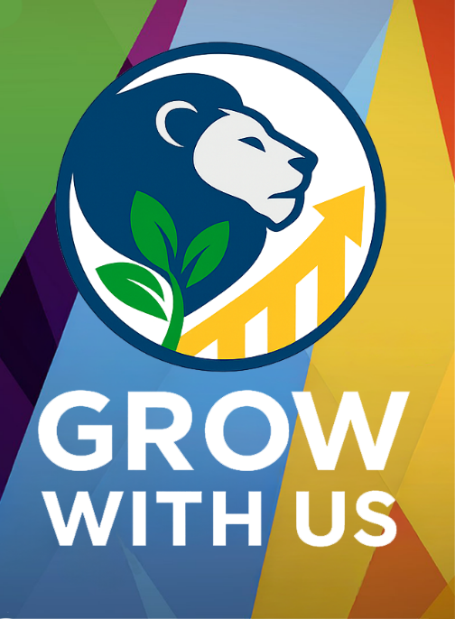
✔️ Reinforce: Consistency builds recognition across all of MD19.

2️⃣ District Growth Team Meetings
How the information flows
Why this matters:
Marketing only works if the information reaches the local level where action happens.
Talking Points
- MD19 Marketing → District Leads
- District Leads → District Growth Teams (GMT, GLT, GST)
- District Growth Teams → Zones, Target Areas, and Clubs
- Each District should confirm:
  - When are your District Growth Team meetings?
  - Who is responsible for sharing:
    - Graphics
    - Instructions
    - Deadlines
    - Support
✔️ Action Item: Each District confirms their next Growth Team meeting date and communication plan.

3️⃣ Lions USA “Let’s Grow” Sessions
You can still register
Why this is included now:
This campaign pairs tools + training. The sessions support confidence and execution.
Key Message
- Lions USA Let’s Grow sessions are still open for registration
- Ideal for:
  - Club presidents
  - Membership chairs
  - Marketing chairs
  - New Lions wanting guidance
- Register Now: https://bit.ly/GrowthWkshp26
- Reinforce: You don’t need to be a marketing expert—this training helps you feel ready.
✔️ Encourage leaders to personally invite at least one club member to attend.

4️⃣ Step-by-Step: How to Post & Boost
Remove friction. Increase participation.
Why this is critical:
If the process feels unclear, clubs won’t boost—even if they want to.
Simple Walkthrough
- Go to the MD19 Marketing Page
- Click Grow With Us
- Select Week 2 graphic (based on your audience)
- Save or copy the graphic
- Go to your club Facebook Page
- Start a post → add the graphic
- Choose a caption from the Caption Library
- Add a Call to Action
- Post
- Click Boost Post
- Select:
- Goal: Engagement
- Button: Learn More or Send Message
- Audience: Local community
- Submit for future reimbursement (if applicable)
✔️ Reinforce: This is designed to take 10–15 minutes.

5️⃣ Sample: What to Turn In
Clear expectations = higher follow-through
Why this removes stress:
Clubs are more likely to participate when they know exactly what proof is needed.
Sample Submission
- Screenshot of:
  - The boosted post
  - Boost confirmation or receipt
- Basic details:
  - Club name
  - District
  - Amount spent
  - Dates boosted
- Optional (but helpful):
  - Reach or engagement metrics
✔️ Message: We are tracking learning, not perfection.

6️⃣ Preview: Week #2 Graphics & Captions
Why Week #2 matters
Why January – Week #2 is different
- Week #1 = Inspiration & Awareness
- Week #2 = Community Impact
- This is where we answer the question:
“What do Lions actually DO?”
Week #2 Focus
- Service
- Visibility
- Real impact in local communities
- Shows prospective members:
  - This is active
  - This is meaningful
  - This is hands-on
Why this timing works
- People are still in a New Year mindset
- They’re looking for:
  - Purpose
  - Connection
  - Ways to give back
- Week #2 builds credibility before asking them to join in Week #4
✔️ Key takeaway: You can’t invite people to join if they don’t first see the impact.

✅ Closing Message to Reinforce
This campaign is:
- Structured
- Supported
- Simple to execute
- Designed to help local Lions succeed
Next Step for Leaders:
👉 Share this agenda with your District Growth Team
👉 Confirm meeting dates
👉 Encourage clubs to post Week #2

