New Club Digital Marketing Assets
Graphic concepts designed to work both on Facebook and LinkedIn, each with clear imagery, on-graphic text, and options for accompanying captions.

1️⃣ “Something New Is Growing Here”

Theme: Curiosity + Community Growth

Design
- Clean, modern layout
- Soft gradient background (Lions blue → light gold)
- Organic shapes or subtle leaf/branch lines

Imagery
- Diverse group of people talking or walking together
- Optional town landmark blurred in background

On-Graphic Text  A New Club Is Starting in Your Town  Grow friendships. Grow service. Grow impact. | 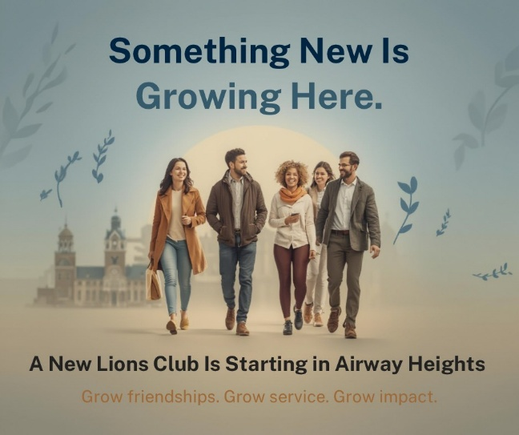

Captions
- Something new is taking root right here in our community 🌱 A new service club is forming—and it starts with people who care. Curious? Let’s talk.
- Great communities don’t happen by accident. They grow when people come together to serve. A new club is starting locally—learn how to be part of it.
- Interested in giving back, meeting great people, and making a difference? A new club is forming in your town. Comment “INFO” or message us to learn more.
2️⃣ “Your Skills Belong Here”

Theme: Purpose + Talent

Design
- Split layout with bold headline on left, photo on right
- Strong typography, confident tone

Imagery
- People collaborating (mixed ages, real-world setting—not corporate)
- Whiteboard, planning table, community setting

On-Graphic Text  Your Skills Can Change a Community  A new club is forming near you | 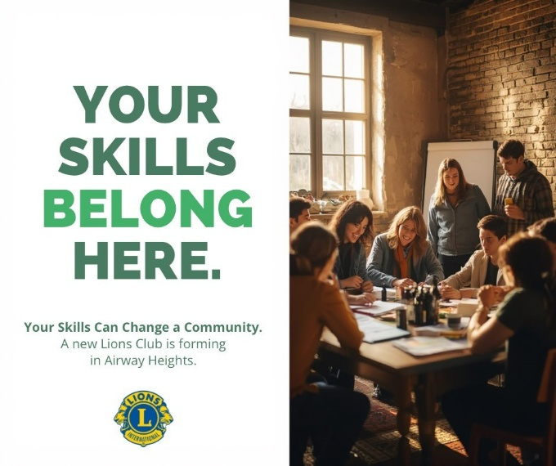

Captions
- Whether you’re great at organizing, listening, leading, or creating—your skills matter. A new local club is forming, and there’s a place for you.
- Volunteering doesn’t mean starting from scratch—it means using what you already know to help others. Join us as we build something new in town.
- Want to use your skills for something meaningful? A new club is starting locally. Send us a message to get involved from the beginning.

3️⃣ “Be a Founding Member”

Theme: Leadership + Ownership

Design
- Bold, high-contrast layout
- Emphasis on the word Founding
- Minimal but powerful

Imagery
- Small group standing together confidently
- Slight upward camera angle

On-Graphic Text  Be a Founding Member  Help shape something meaningful | 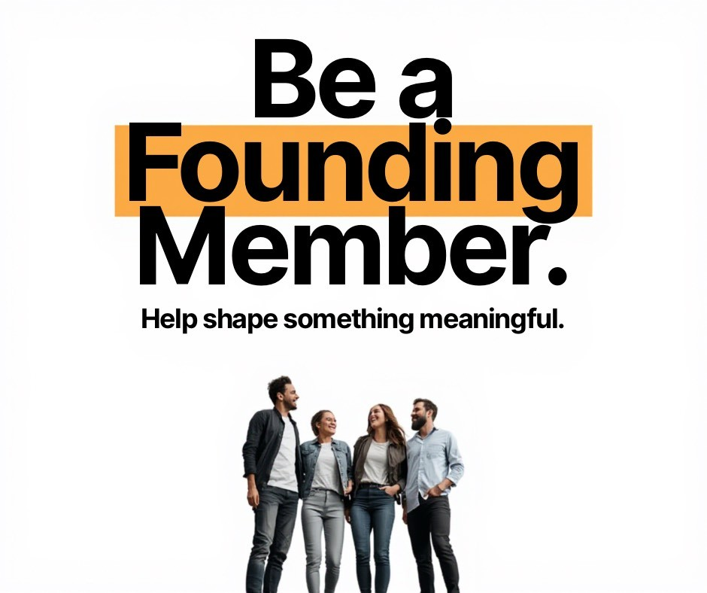

Captions
- This is your chance to help build something from the ground up. A new club is forming—and founding members help set the tone, culture, and impact.
- Founding members don’t just join—they lead. If you want to help shape a new service club in your town, we’d love to talk.
- Be there at the beginning. Be a founding member of a new local club. Message us to learn how.

4️⃣ “Service, Friendship, Purpose”

Theme: Emotional connection

Design
- Warm color accents
- Rounded shapes, approachable feel

Imagery
- Smiling people in casual clothes
- Community event or outdoor setting

On-Graphic Text

Service. Friendship. Purpose.
A new club is starting near you

Captions
- People are looking for more than meetings—they’re looking for meaning. A new club is forming that blends service, friendship, and purpose.
- Serve your community. Make real friends. Feel connected again. A new local club is starting—come learn more.
- If you’ve been looking for a place to belong while making a difference, this might be it. Message us to learn about the new club forming in town.

5️⃣ “Built for Today’s Lives”

Theme: Modern + Flexible

Design
- Clean lines, modern fonts
- Phone-friendly layout

Imagery
- Casual meetup scene (coffee, park, shared table)

On-Graphic Text

A Modern Way to Serve
Flexible • Local • Meaningful

Captions
- Service should fit real life. This new club is designed for today—flexible, welcoming, and focused on local impact.
- You don’t need more obligations—you need meaningful connection. A new club is forming with modern schedules and real purpose.
- Looking for a way to give back that fits your life? A new local club is starting. Reach out to learn more.

6️⃣ “It Starts With One Conversation”

Theme: Low-pressure invitation

Design
- Soft background
- Emphasis on conversation, not commitment

Imagery
- Two people talking or a small group laughing

On-Graphic Text

It Starts With a Conversation
New club forming in your town

Captions
- No pressure. No commitment. Just a conversation. A new club is forming locally—let’s talk about what it could look like together.
- Big impact often starts small. If you’re curious about a new service club forming in town, we’d love to chat.
- Interested? Just ask. A new club is forming, and it all starts with a simple conversation. Message us anytime.

